Basic of c

.exe file is a software

Their are two types of software

1. Application software -> these are ment to be for the user
2. System software -> these are ment to be for machine

These are the software which they are running in brackgound as a UI.

Set of instructions in called program ( ex planning)

And the active state of program is called process

Understanding of execution of file

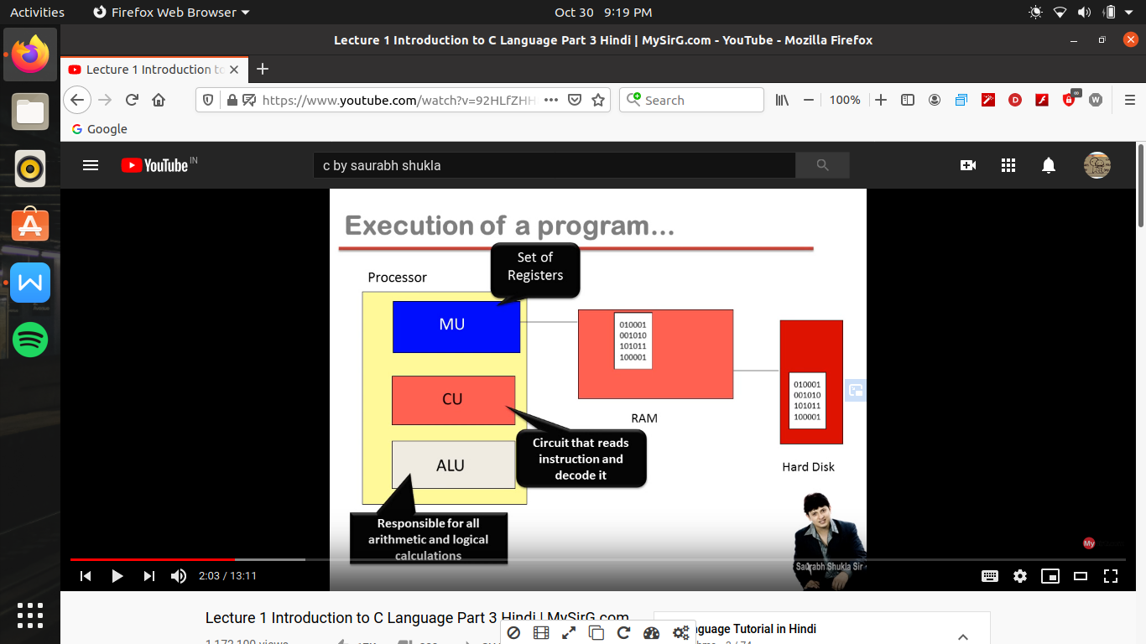

First , the software store in the hand drive (i.e .exe file)

When we run a file so firstly what happen is

A copy of that software load in ram

And yeh operating system ki kimde dari h ki program ke chalane ke leye memory ka allocation karwaye

1. i.e called as memory management

Once the memory is allocated to the program then execution of the instruction will start

Hamare program me bahot sare instructions hai or 16 bit architecture ke hisab se pahale 16 (0 or 1) in the first instruction and next 16 ( 0 or 1) in the next instruction

As per one by one their are many instruction were written in the program

1. i.e ek instruction ka size fix hai i.e 16 bits

Now to execute the program

The first instruction (i.e 16 bits) gone to processor

Processor ke pass hota h bahot sare memory unit jaha pr bahot sare chote chote momery device hote h this memory device is called as resistors

On all of those resistors , their is one resistor which knows as instruction resistor, on the instruction resistor instruction

Ja kr store ho jayegi

And as per 16 bit principle , the instruction resistor bhi 16 bit ka hota hai ( yeh 16 bit is me likha hai ki kya karana hai computer ko )

Control unit ek circuit hai processor ke andar ji ka kam h ki padana , ecode karana or samajha ki kya meaning hai and then it give signal to ALU ki tum ko yeh kam karana hai

ALU ki har tarike ka calculation perform karata hai

System ke andar

ALU apani marji se kuch nhi karega jaisa CU bolega waise karega and ALU will execute the instruction

So by this process first instruction will execute

Or bari bari sari instruction will run by following process and when all the instruction runs then the our program will end

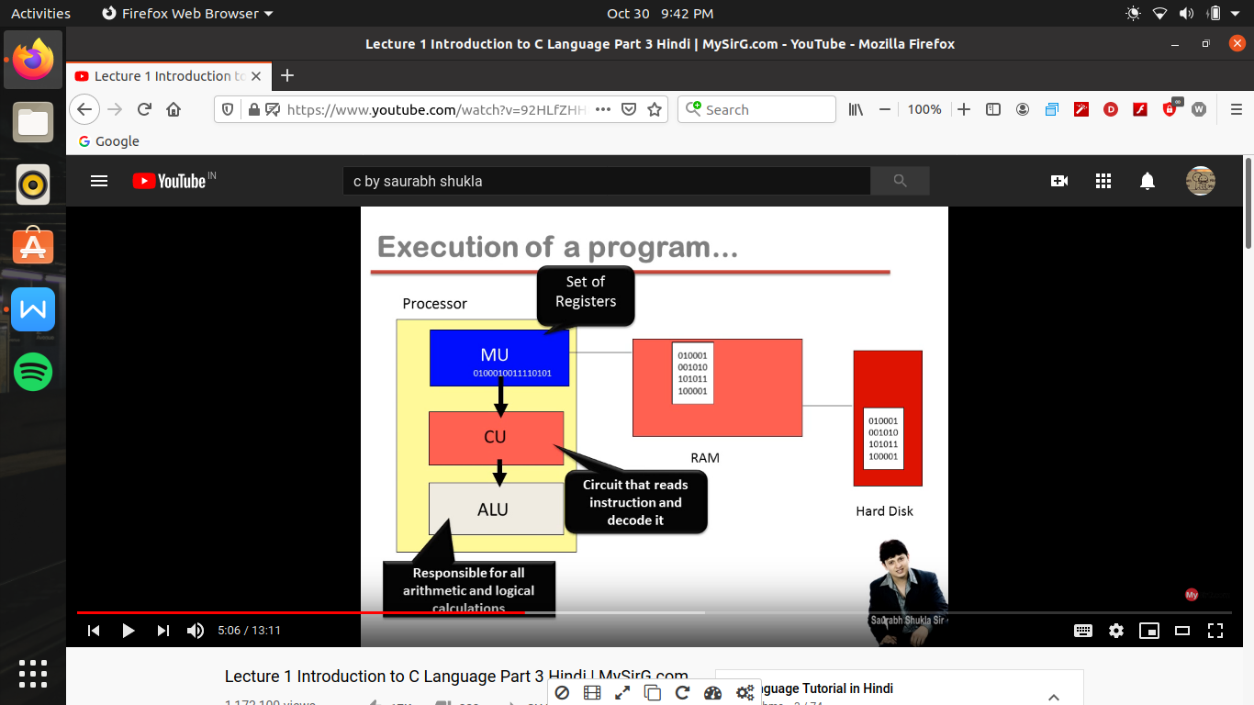

HOW TO MAKE A SOFTWARE

Now for this we have to make a .exe file b/c exe file hi software hai

Let assume we have to make a software named as sum.exe

But es file ko banane me ek dikhat yeh hai ki yeh ek operating system dependent language me hai

1. e agar yeh file dos os ke samajane layak hai toh yeh kisi or os me samajh nhi ayegi)

Tabhi jab bhi koe software banata hai toh particular os ke respect me banata hai

1. e we have to learn alag alag lanugage for the alag alag operating system)

Tabhi sab se asan tarika yeh hai ki hum asan ki language seekhe jo ki hai c_language

C_language me jab hum file banate h toh use kahate hai source file jis ka extension .c hoga

But this is not the software

So to convert this .c file first we have to run the software called as preprocessor

Preprocessor kya karega ki source file me jitane bhi line # se start ho rahi hai us ko handle karane ka kam preprocessor karata hai

Es me kuch (header file ) name ki file hoti hai jise hamane nhi banaya hai but jis hamare program me jodana jaruri hai but hum ne program me kuch aisi line likhi hai jis se preprocessor header file ke content ko hamari file ke content me mix kr deta hai

Or ek nayi file bana deta hai or yeh nayi file , yeh nayi file hamari file jaisi hi hai bs es me # se start hone wale statement hat chuke hai or kuch nayi lines a chuki hai

1. e preprocessor # se shuru hone wale statement ko handle karata hai es me es ek bahot ki popular command hai “$ #include<filename>” which means i.e file me jo bhi content hai es ko hamari file ke sath jod do to preprocessor “$ #include<stdro.h>” file ko hata dega or header file <stdro.h> me jo bhi likha hoga use add kr dega

Now the “.i ” file made by the preprocessor , now by the help of compiler software hume karana hai translate

Ab compiler hamare program ko translate kr ke ab yeh ek nayi file bana dega jis bolate hai hum object file (.obj)

Yeh object file kisi bhi operating software ke hisab se bani hai

(compiler alag alag os ke hisab se alg alg ate hai)

Now we need library files because in the object files aisa bahot kuch likha hai jo operating system nhi samajh payega or un ka meaning library lifes me pahale se likha hai

( like a dictionary jo word nhi samjh ayega toh wo library files se meaning nikalega)

Now library file ka code or object file ka code hum ek software use karege use bol dege linker

Linker object file or library file ko mix kar ke ek nayi file bana dega i.e .exe file now by this we made a software

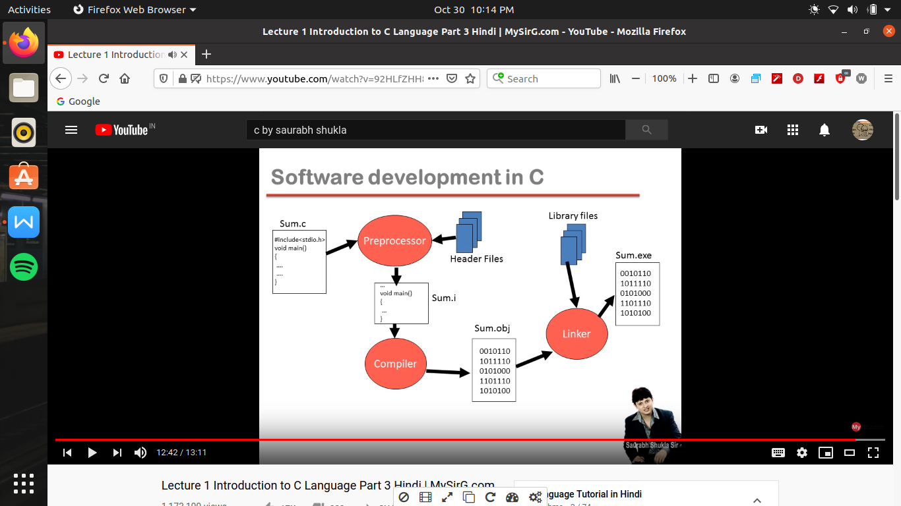

Lecture -2 part 1

Identifiers in c ->

First as like we learn alphabet first and then we try to make words so in c words are represented by identifiers

Now we learn to make sentence that in c knows as instructions and when we how to make instruction then we came to know how to make program

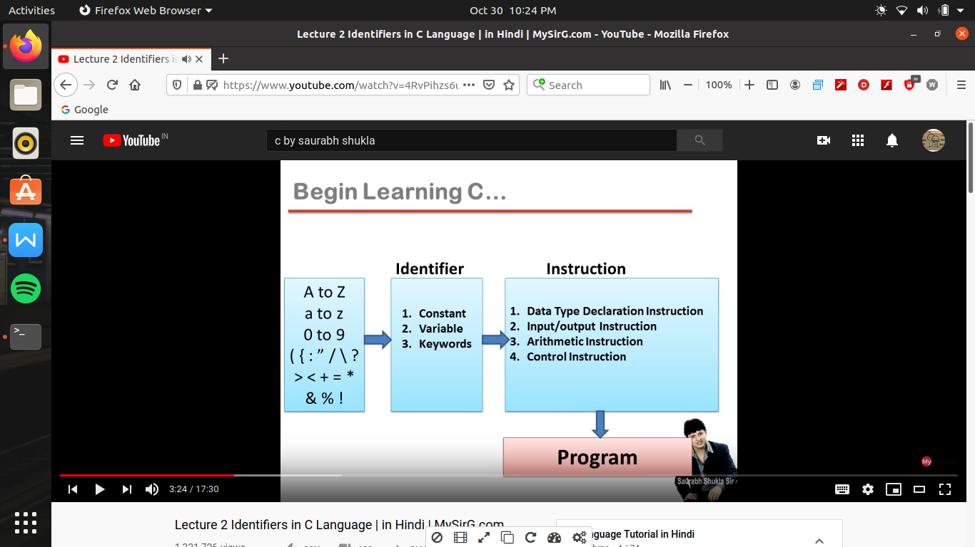

Type of Identifier ->

1. Constant -> any software is maneging some kind of instruction and that information is called as constant

We can say constant or information or data ek hi bat hai

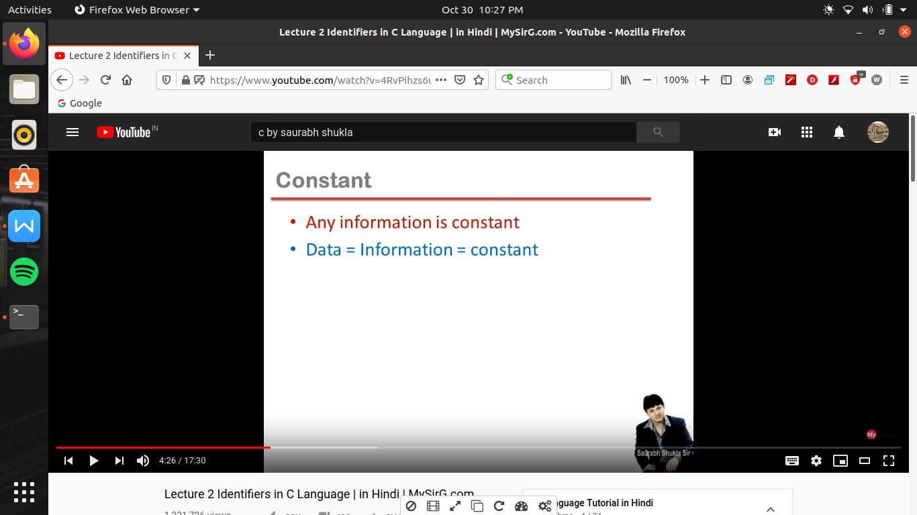

And the type of information we receive , for to understand this we divide this constant into two parts

1. Primary constant
2. Secondary constant

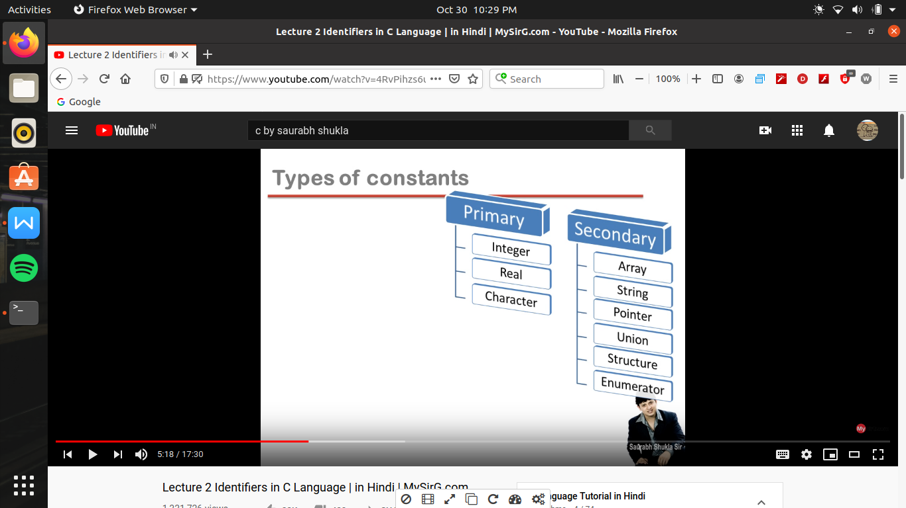

1. Primary constant ->

Integer constant are those which are any no. Or us me point nhi laga ( -55,6,3,-24, 2)

Real constant are those no which have points ( ex 24.4 , 65.3 , -0.002 , 2.0)

( in c their is difference b/w 2 or 2.0)

Chracter constant are those those all symbols with which we use single coats(‘’)

Ex- ‘e’, ‘=’, ‘+’ ‘2’

Note - space is also a charater constant (ex - ‘ ’)i.e a space is given in between single coats

Digit also can be character constant

Note -> charater constant ki ek shart hai hai single coats ke andar ek hi symbol hona chahiye i.e why ‘-3’ is not a charater constant ( like ‘3.4’ or ‘shashank’)

Mobile no. Is a interger constant

But balance is a real constant b/c point me bhi ho sakta hai

And if ek se jayada charater constant ko mil de toh es bolate hai string

( ese hum double coat(“”) ex- “kanpur”

1. Secondary constant ->

These are the constant jo primary constant ki sahayata se banate hai

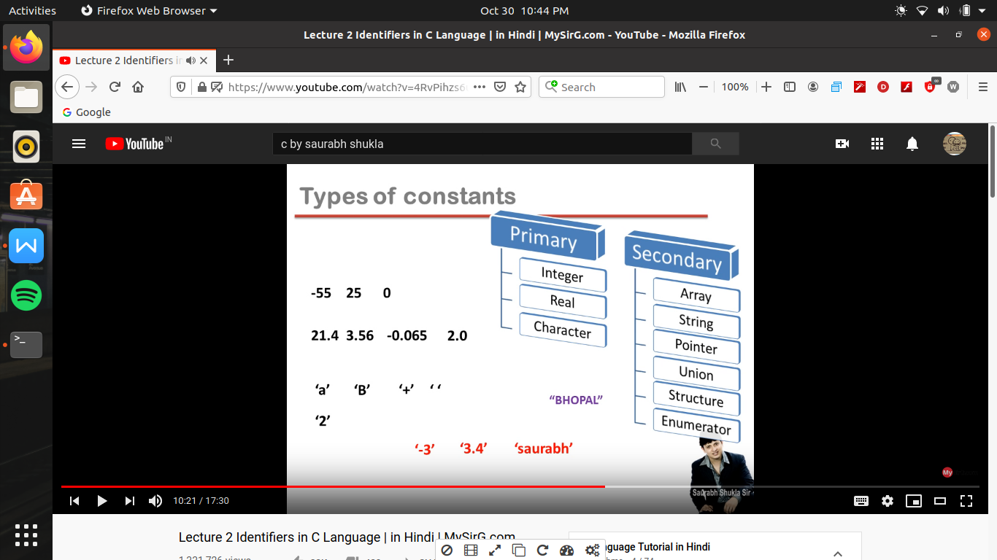

Process memory -

To run a program use ram me kuch memory milati hai

Or agar 16 bit architechture ki bat kare 16 byte ki memory mili hai

Hamare program ko 2 tarike ke leye memory milati hai first instruction ko rakhane ke leye or dusara data ko rakhane ke leye

Instruction ko rakhane ke leye jo memory mili hai us me hamare program ki instruction store ho jayege

Or baki ki jagah me data rakha ja sakata hai

Kisi bhi program me 2 main chij hoti hai instruction or data.

Program me instruction data ko use karate hai task karane ke leye

But hame data rakhane ke leye thodi si jagah chahiye hoti hai toh hum ek khas line likh kr compiler ko batana hota hai ki hame kitane jagah ki jarurat hogi data rakhane ke leye

( ex - jab hum program banate hai toh hame pata karana hota hai kitani jagah chahiye

Ex- hame 2 no. Ko add karana ho toh hame 2 no. Ko handle karana hai or sath me us ke result ko toh hame total 3 no. Ko handle karana hai

Toh hum line likh kr utani jagah magate h jitana data ko store karana hai only jab tab tak hamara program run ho raha hai

And this space having a name and this name we can allocate any thing by ourself ( we given name as a,b and c)

So these a , b ,c are called as variables

I.e variables are the name of memory storage where we store our data

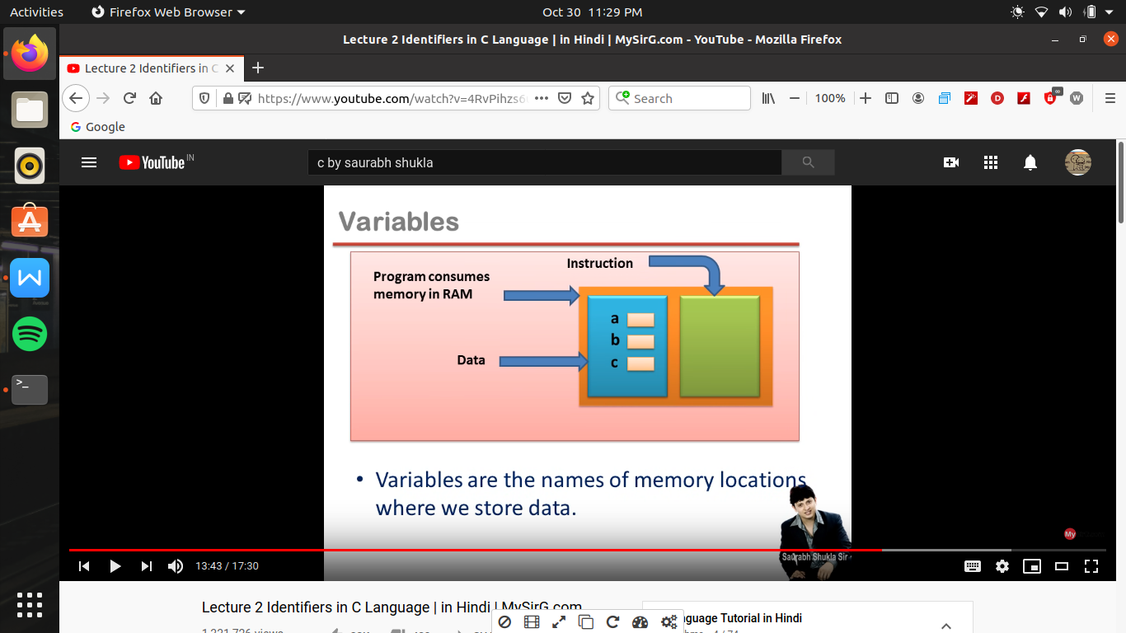

Now their is a rule to assign the name of variables such as :-

1. Hum alphabets (either in capital or in lower case) or underscore(_) ke alawa or koe digit use nhi kr sakate

Note -> c language is a case sensitive language

(it doesn’t mean that we have to write only in lower case)

1. Variable ka nam kabhi bhi digit se start nhi ho sakata

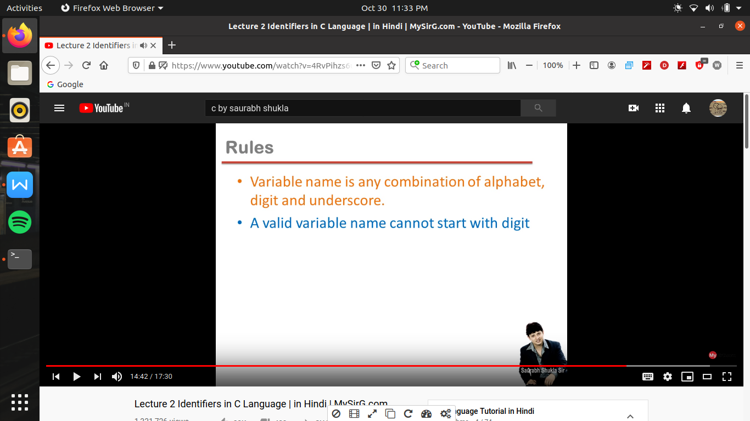

Keywords ->

These are those words jis ka meaning hame compiler ko batane ki jarurat nhi hoti use pahale se hi pata hota hai toh use keywords kahate hai

Keywords ko ki predefined words ya reserved words bhi kahate hai

There are 32 keywords in c language for 16 bit architecture

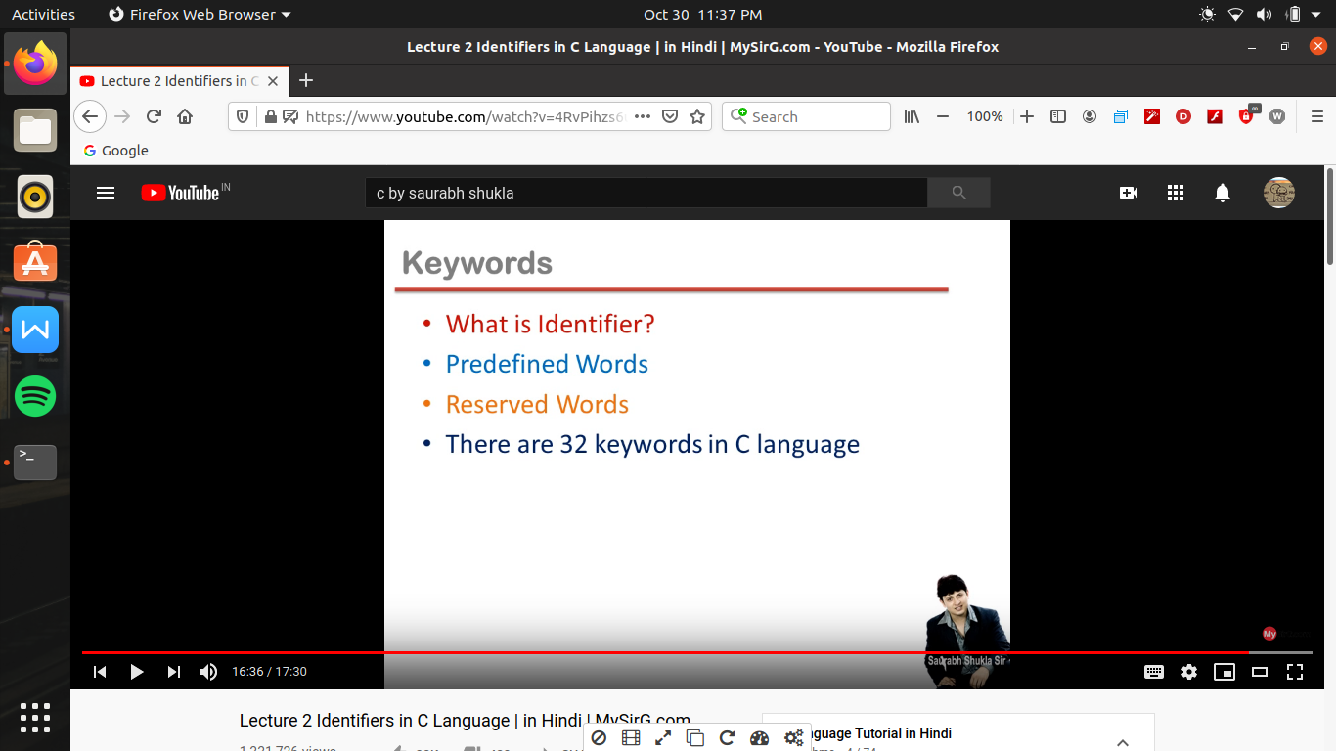

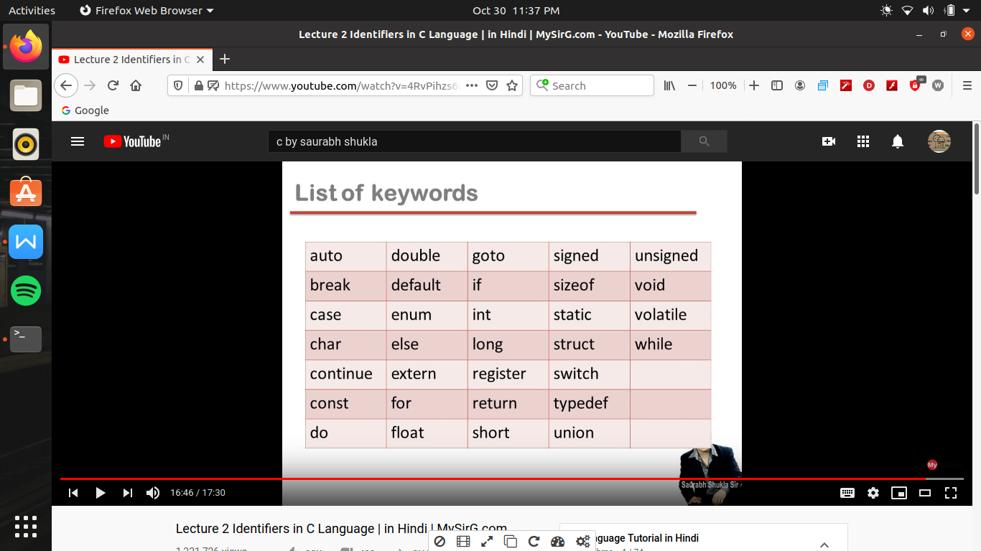

( ese alag se yad karane ki jarurat nhi hai jaise jaise programming karage apane app yad hone lagega)

Note -> these words are predefined or es ka use hum variable ki tarah nhi kr sakate or yeh sab lower case me hai

Lecture 3 part -1

Instruction->

Program statement are called instruction

Instruction are command

Type of instruction :-

1. Data type declaration instruction
2. Input output instruction
3. Arithmetic instruction
4. Control instruction

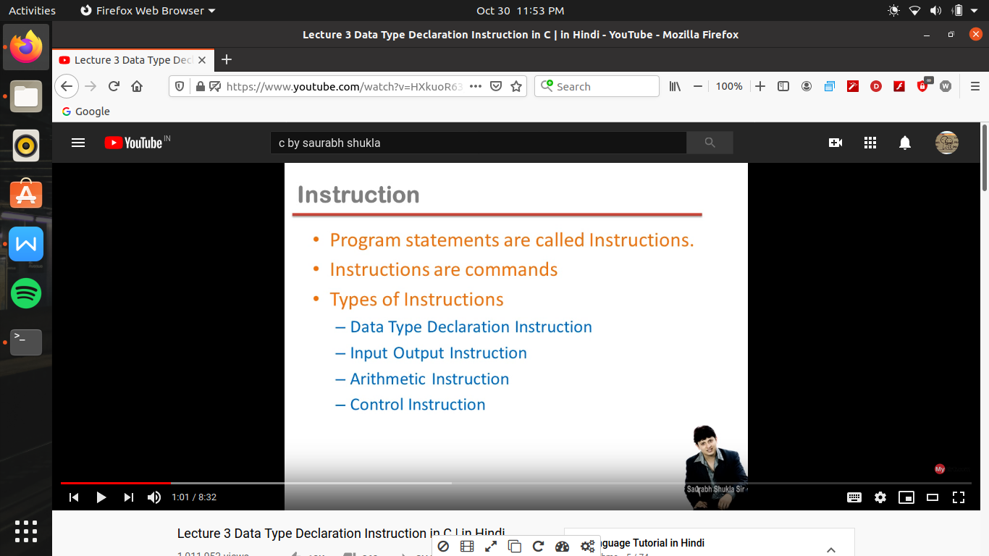

Data type->

In c language their are 5 keywords which we also called as data type

1. int
2. char
3. float
4. double
5. void

( all are in lower case)

Data type en sab ke alawa bhi ho sakate hai pr wo hum ko banane padate hai

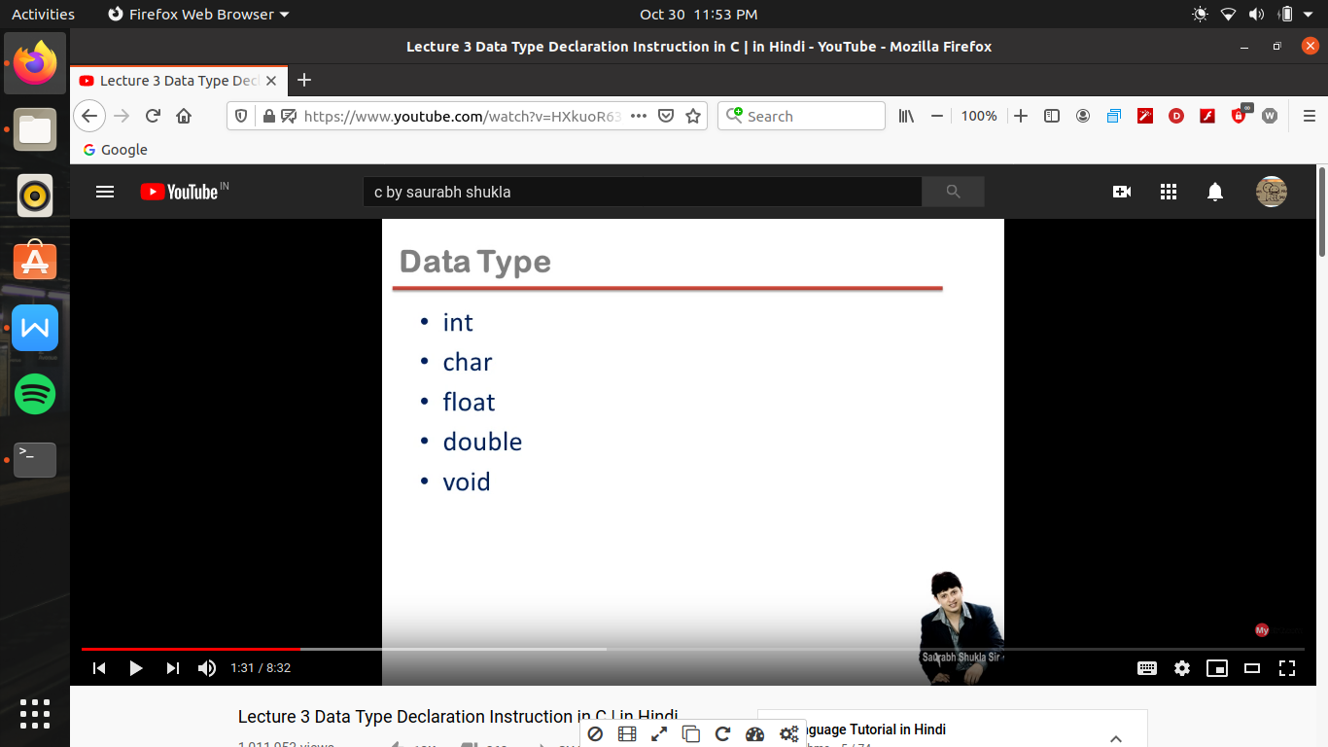

Primitive data type ->

Those words which are keyword and also data type are knows as primitive data type

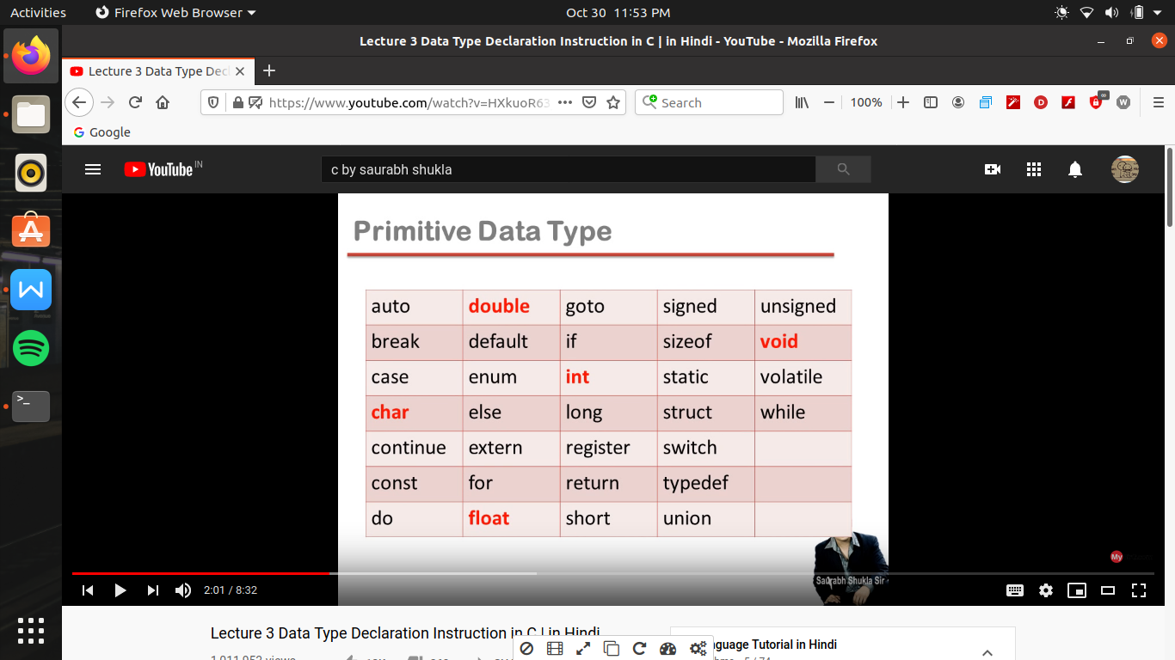

Data type Declaration statement :-

Ex->

If something is written as

“ int a,b=5;” -> jab bhi compiler aise tarah ki line hamare program me deekhega toh wo samajh jayega ki yeh data type declaration hai jis ka pahale word koe data type declaration hi hona chahiye or ek se jayada ek line me data type use nhi kar sakate

if we write “int” then the compiter undersatnd that now we are going to make the variable

By data type declaration we decide that how much variables we have to make to for according to this we demand for space

If we write “int “ then es ke help se banane wala variable 2 bytes(not bit) memory leta hai (b/c hum yaha dose base architecture pad rahe hai) and store only integer constant

(but window base architecture me “int” 32 bit memory leta hai yani 4 bytes)

Now float ki madat se banane wale variable ko 4 byte memory milati hai & store only real variable

Char ki help se banane wale variable ko 1 byte memory milati hai and store only character constant

And double ki help se banane wale variable ko 8 byte memory milati hai & store only real variable

If we write as “int a,b=5”

Here we made two variables

In Variable a we did not assign only value thus having unpredictable value and this value is know as garbage value

Toh sabhi value jis me hum ne initialize nhi kiya hai wo garbage value rakhi hue hai

Hum decleration ke bad bhi variable me value initialize kar sakate hai toh yeh zaruri nhi hota jab hum decleration kar rahe hai toh usi waqat value bhi intialize kare

In variable b=5 (read as b assign 5) (not read as equal to here) and this is known as assignment operator

Here in b we store 5

Yeh declaration compiler ke leye hote hai ki jab hum pure program me en variable ka use karege toh compiter ko es ka mean pata chalega

Or en ke alawa jo bhi lines hum apane program me likhate hai use action statement kaha jata hai or c language me yeh rule hai ki har block me decleration statement , action statement ke pahale hi hona chahiye

Agar hum action statement pahale likhege or decleration statement bad me likhege toh error ayegi

( but c++ me action statement ke bad bhi declaration statement likh sakate hai)

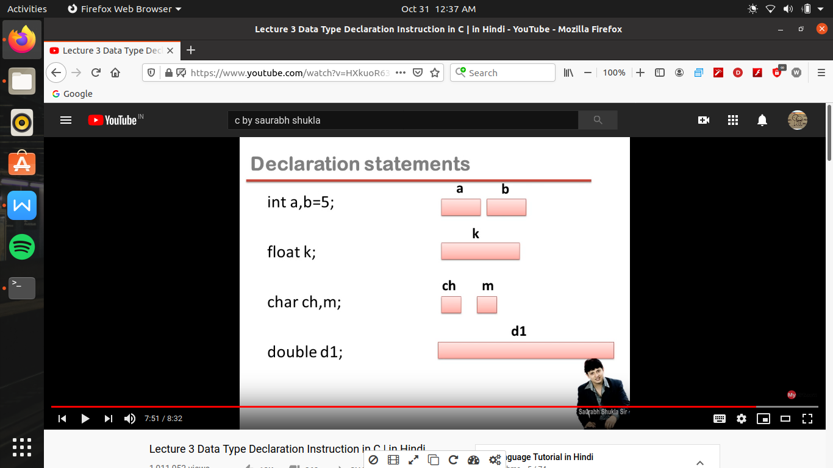

Lecture 4 part1

Input and output instruction in c ->

Waise toh bahot sare input and output devices hote hai compute me pr

Standard input and output devices are keyboard, monitor respectively

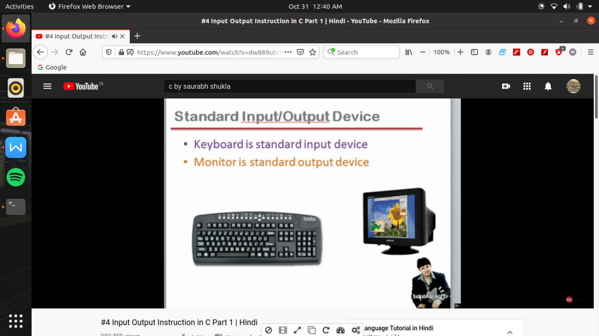

Output instruction ->

Aise instruction jo ki run karane pr monitor me koe information print hota hai (i.e screen me kuch print karana ki output kahalayega)

Predefined function : (these are the ready made code already assign which perform a particular task)

1. Printf() -> it is not a keyword, it is a predefined function

It is a function , jis ka kam hai screen me message print karwana

(aisa hum bhi apane se funtion bana sakte hai)

1. We can use this for a message as it is
2. Or we can use to print a value of a expression

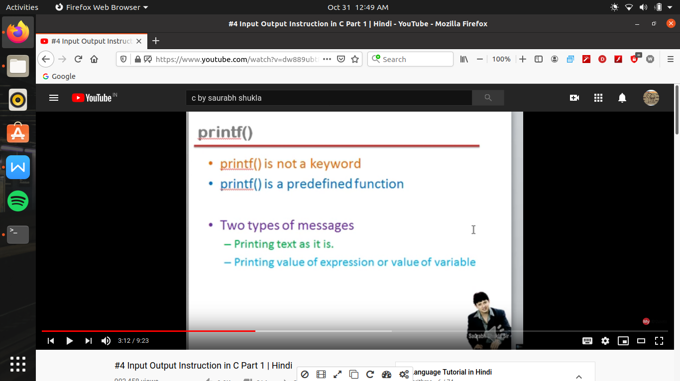

(we are here learning 16 bit arcitecture wali c language sikh rahe hai jis me hum console based programing hi kr sakate hai , control based programming mtlb wo jo black ya blue screen milati hai ms dos ki usi me hum keval text based interaction kr sakte hai so jo bhi hum print karawa rahe hai wo text based hai )